Tenant = The top-level identity container that holds all users, groups, applications, and permissions for an organization.
Tenant is the identity container.
Example:Default Directory
Without a tenant, Azure has no place to store identities.
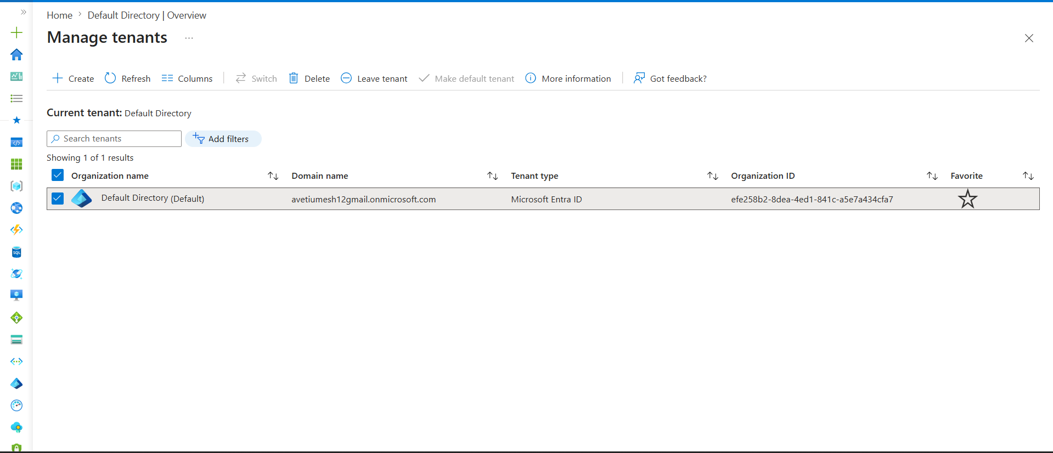
Azure creates default Tenant for us
Create tenant by your own
-----------------------------------------------
Manage Tenants
↓
Create
↓
New Tenant
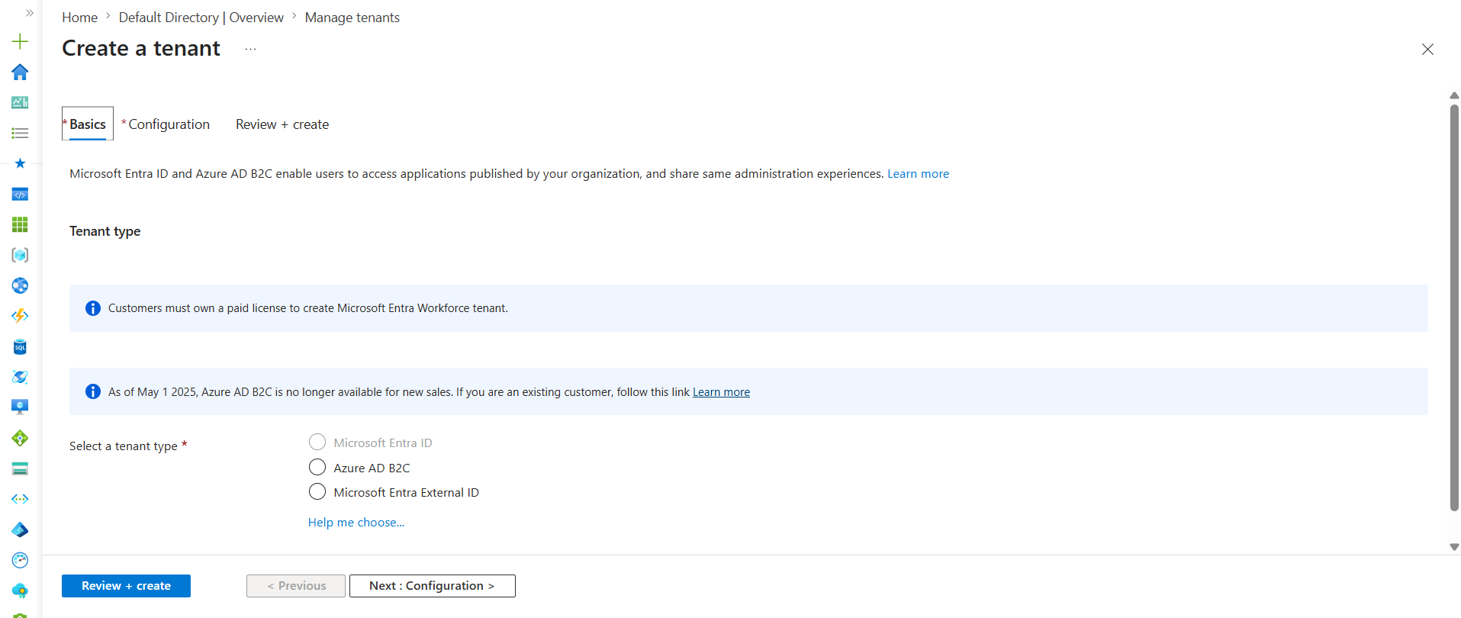
Tenant → Users → Groups → Roles → Resources
Default Directory Tenant
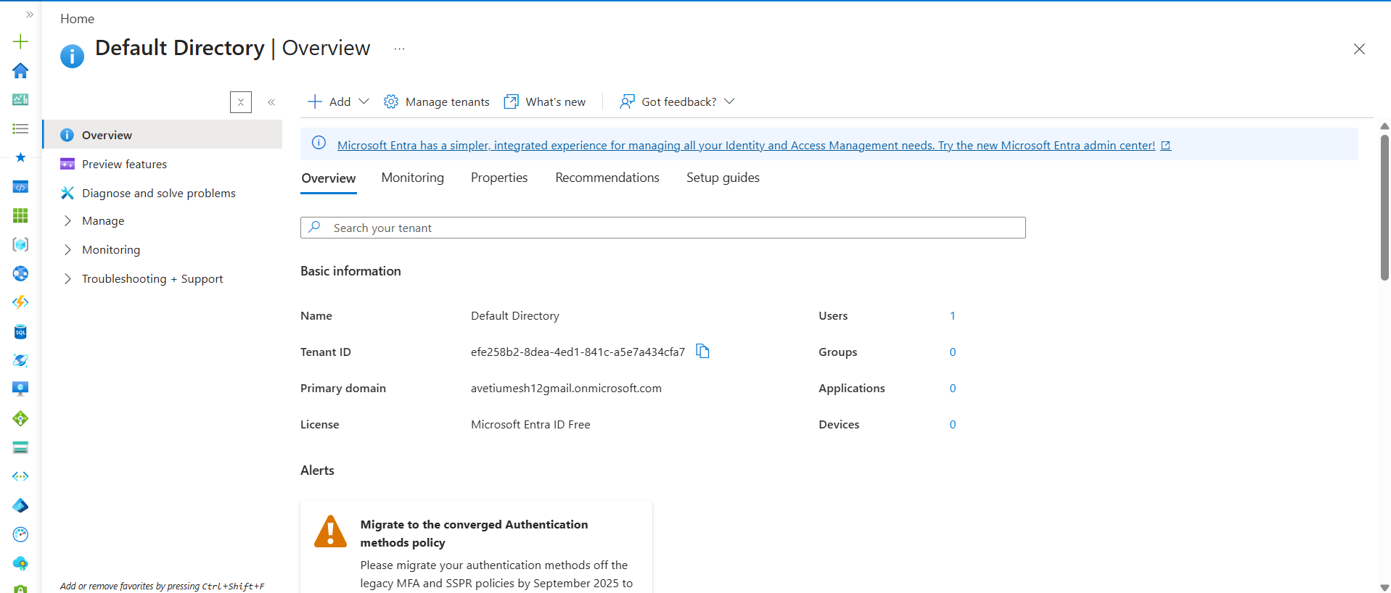
After the Tenant is available, the very next thing is usually Users.
Think of it like this:
Tenant
↓
Users
↓
Groups
↓
Roles (RBAC)
↓
Azure Resources

Users
Users are the people or identities that need access.
Example:
Default Directory
├── Umesh
├── Ravi
└── Priya
Question:
Can Azure assign permissions to someone if that user doesn't exist?
No.
That's why users come first.

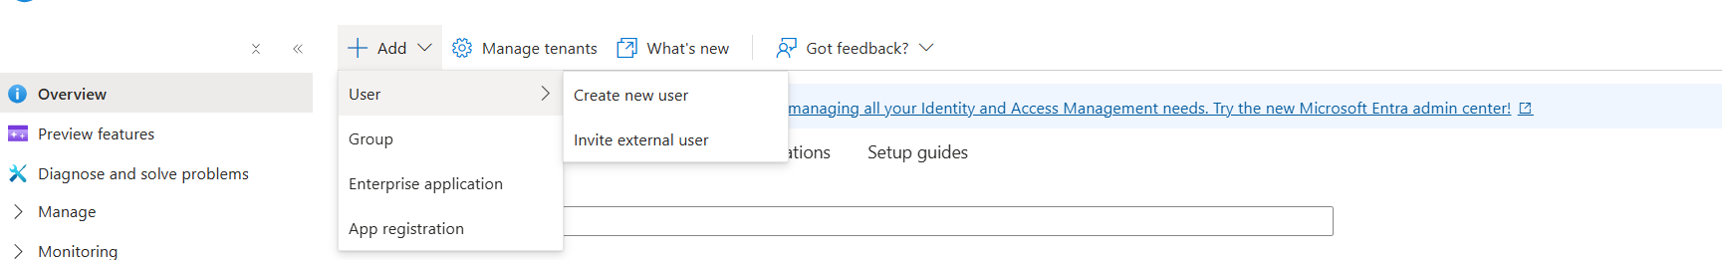
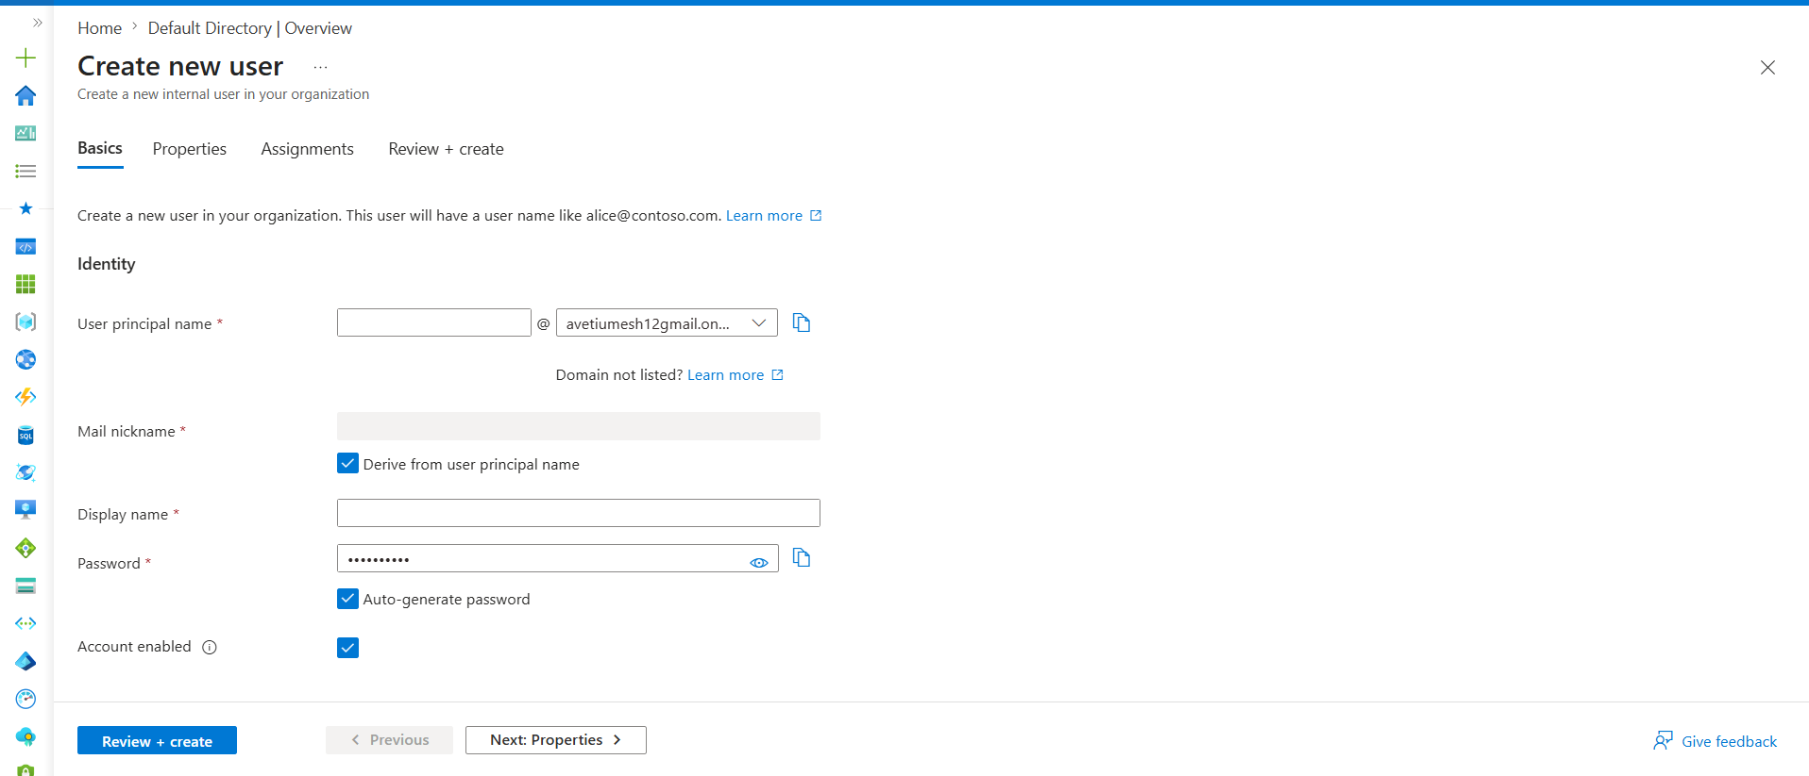
1. User Principal Name (UPN)
This is the login ID of the user.
Example:
devopsadmin@avetiumesh12gmail.onmicrosoft.com
When the user signs in, they use this username.
Think:
AWS IAM User Name ≈ Azure UPN

2. Mail Nickname
Usually auto-generated from the username.
Example:
UPN : devopsadmin@...
Mail Nickname : devopsadmin
You rarely worry about this as a DevOps Engineer.

3. Display Name
This is the friendly name shown in Azure.
Example:
Display Name : DevOps Admin
When admins search for users, they'll see this name.

4. Password
The initial password for the user.
Example:
TempPassword@123
When the user logs in for the first time, they may be asked to change it.
5. Account Enabled
✓ Enabled
User can sign in.
✗ Disabled
User exists but cannot sign in.
Real-world example:
An employee leaves the company.
Instead of deleting the account immediately:
Disable User
Now the user can't access Azure.

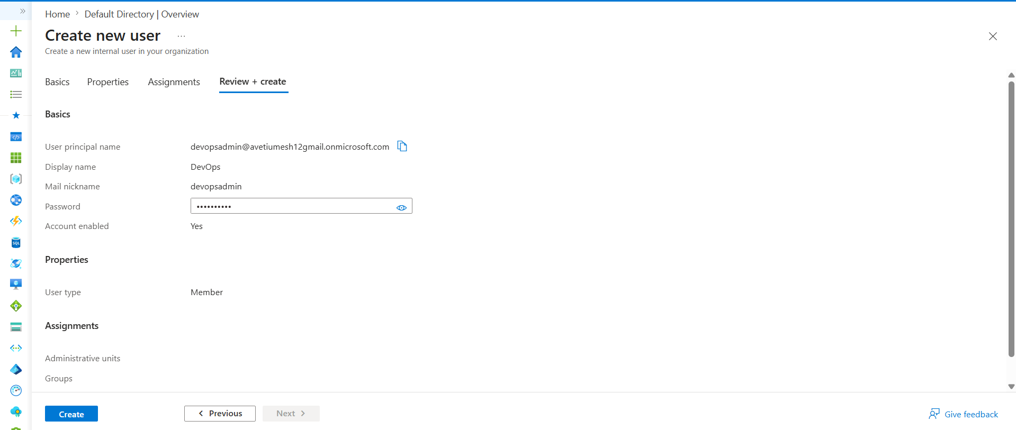

User created

We have 2 users here >> click on users
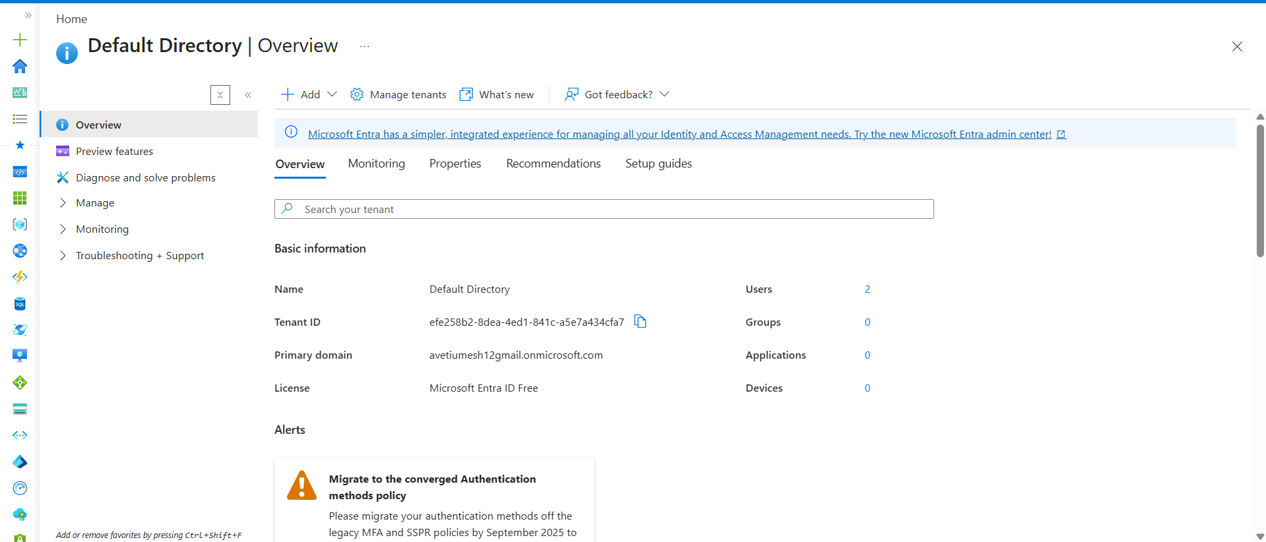

User 1 (Already Existing)
Umesh Aveti
This is the account you used to sign up and log in to Azure.
When Microsoft created your Azure account, it automatically added this user to the tenant.
User 2 (You Created)
DevOps
(devopsadmin@avetiumesh12gmail.onmicrosoft.com)
This is the user you manually created.

Groups are not mandatory before RBAC. Permissions can be assigned directly to users using RBAC. However, in enterprise environments, permissions are usually assigned to groups instead of individual users. This makes access management easier because adding or removing a user from a group automatically grants or removes permissions.
The recommended approach is User → Group → RBAC → Resource, while User → RBAC → Resource is commonly used for testing and learning.

Next Group

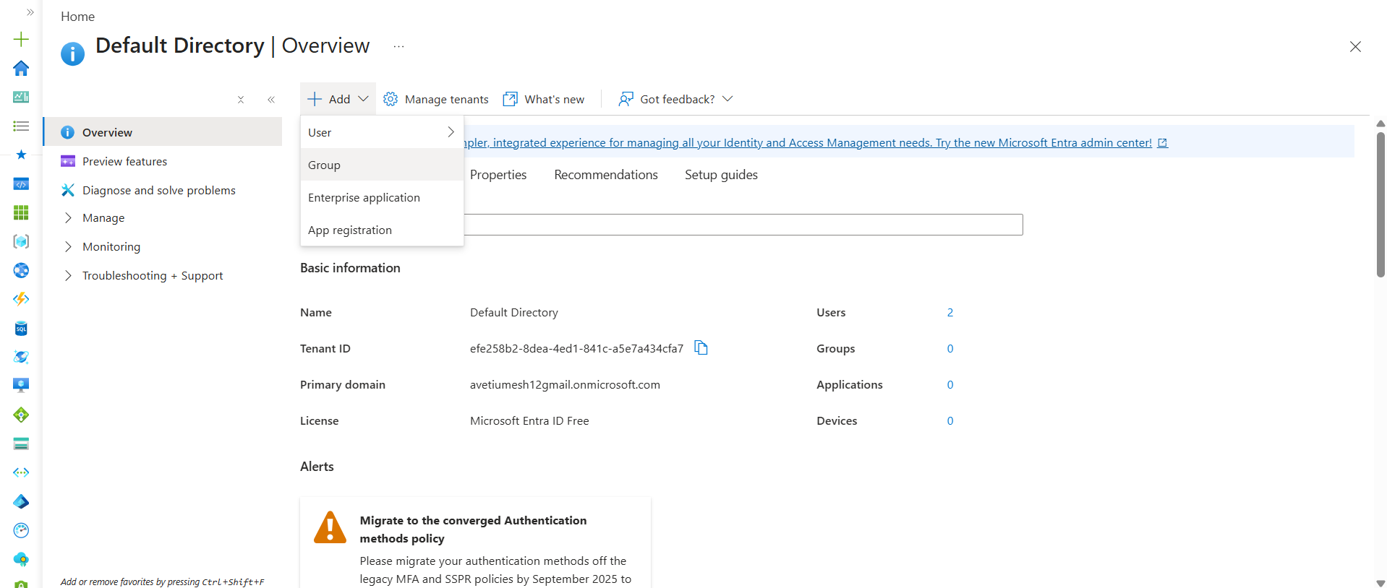

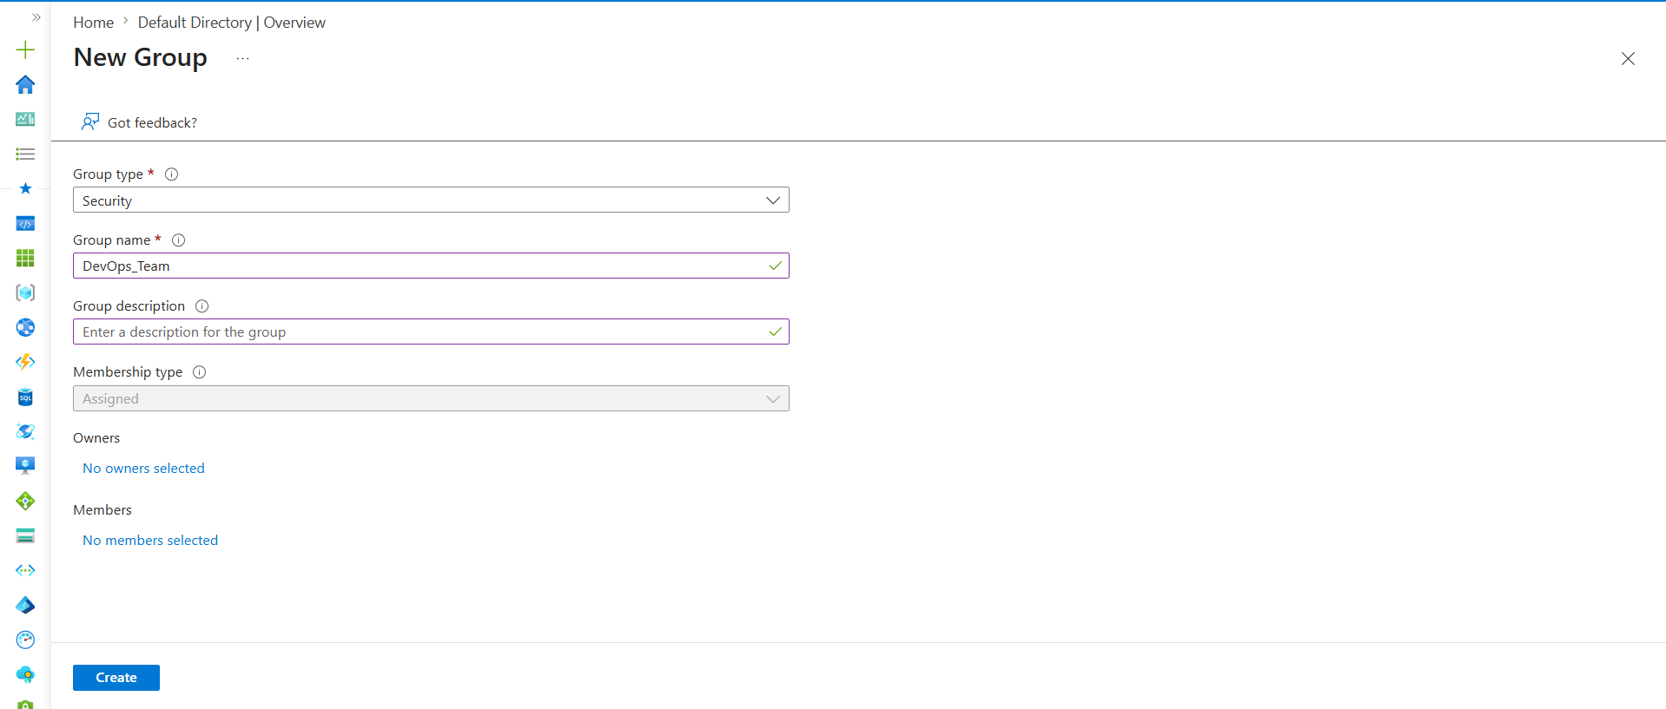
Group created and user added to Group
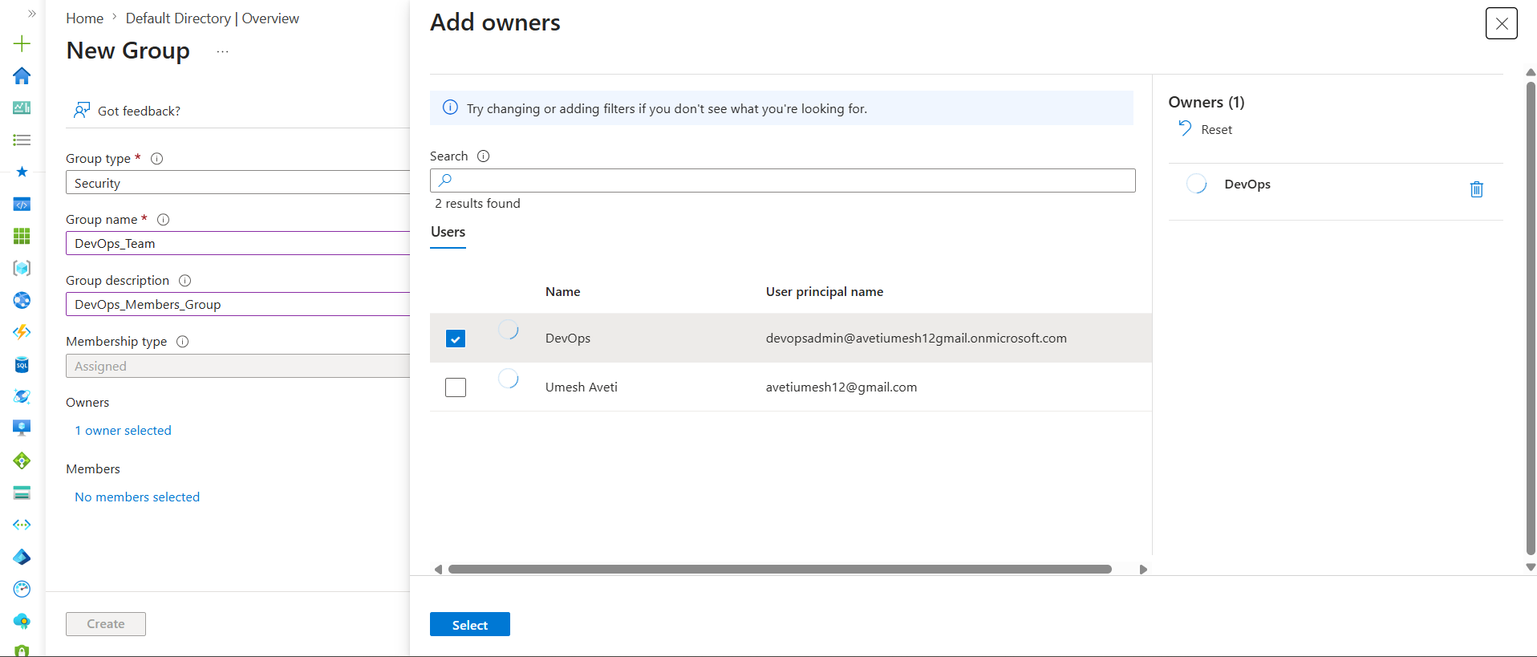
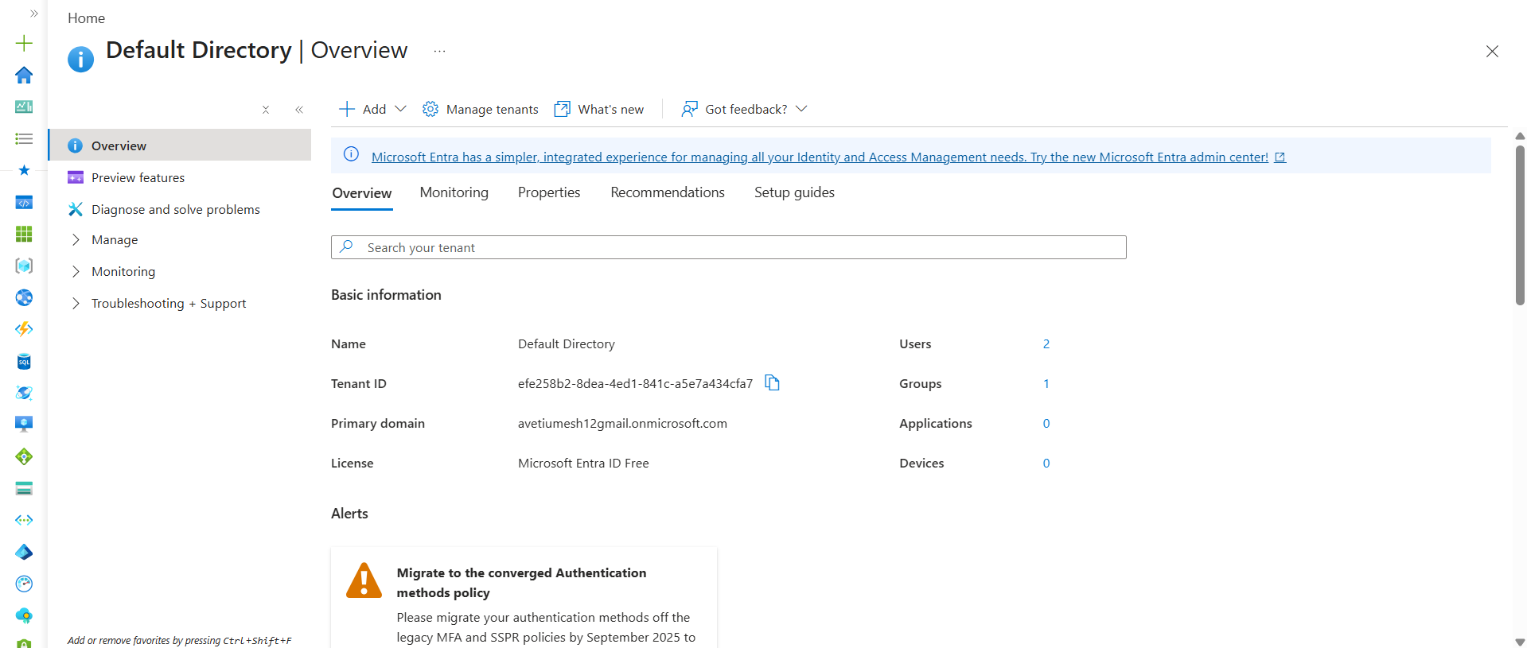
Azure Groups are used to manage multiple users together. Instead of assigning RBAC permissions to individual users, permissions are assigned to a group. All users added to the group automatically inherit the assigned permissions. This simplifies access management and is the recommended approach in enterprise environments.
The typical flow is User → Group → RBAC Role → Azure Resource.

What is RBAC?
RBAC stands for Role-Based Access Control.
RBAC decides:
What actions can a user or group perform on Azure resources?
Easy Understanding
Creating a user only answers:
Who are you?
RBAC answers:
What can you do?
Until a role is assigned.
After RBAC
DevOps-Team
↓
Contributor Role
↓
Resource Group

RBAC (Role-Based Access Control) is Azure's authorization mechanism used to control access to resources. It determines what actions a user, group, service principal, or managed identity can perform. Common built-in roles include Reader, Contributor, and Owner. RBAC permissions are assigned at a specific scope such as Subscription, Resource Group, or Resource.
The typical access flow is User → Group → RBAC Role → Azure Resource.

What is Contributor Role?
A Role is a collection of permissions.
Instead of manually giving:
Create VM
Delete VM
Create Storage
Modify Storage
Create Network
Delete Network
Azure bundles these permissions into a role called:
Contributor
Why do we need it?
Suppose your manager says:
Give the DevOps team access to manage resources.
Instead of assigning 100 individual permissions, Azure provides:
Reader
Contributor
Owner
Contributor Role Means
Can View Resources
Can Create Resources
Can Modify Resources
Can Delete Resources
Cannot Grant Access to Others

Domain = "Who belongs to this organization?"
Group = "How do I manage many users together?"
RBAC Role = "What are they allowed to do?"

A role assignment always needs 3 things:
Who? → User / Group
What? → Role (Reader, Contributor, Owner)
Where? → Scope (Subscription, RG, VM, Storage)

Portal Steps
- Go to Resource Groups
- Open a Resource Group (or create one if you don't have one)
- Click Access Control (IAM)
- Click Add
- Click Add Role Assignment

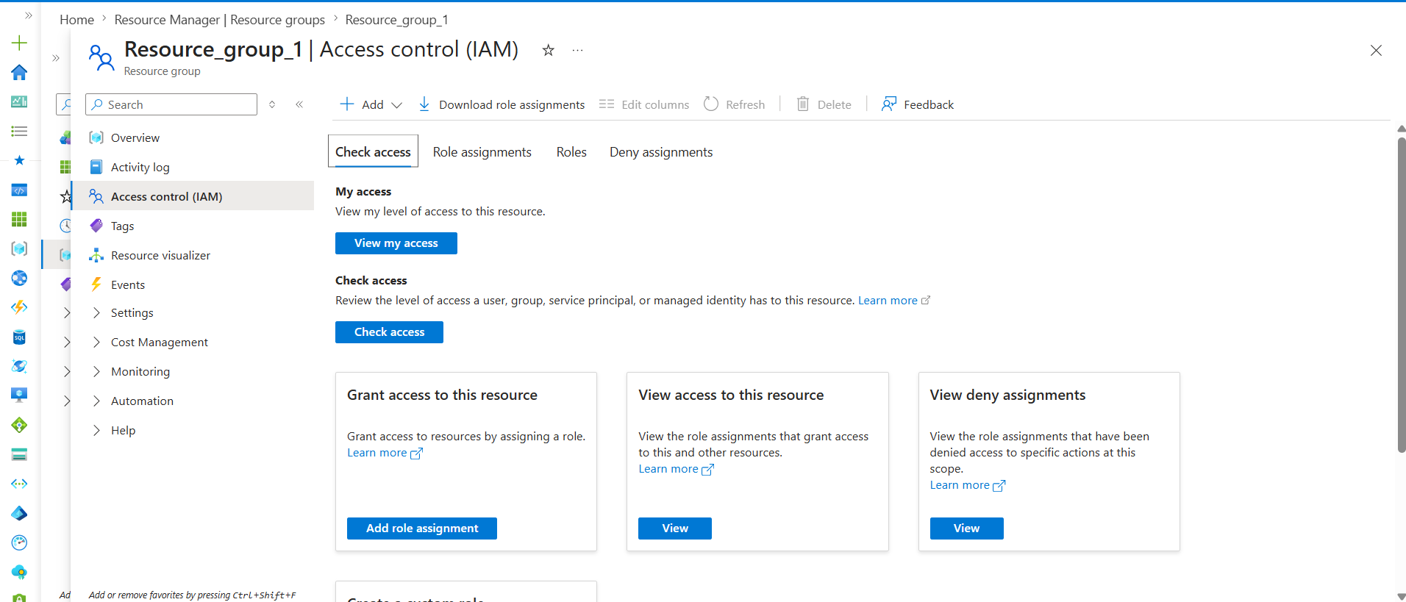
Then Azure asks:
Select Role
↓
Reader / Contributor / Owner
Next:
Assign Access To
↓
User / Group
Select:
DevOps-Team
or
DevOps
Finish the assignment.
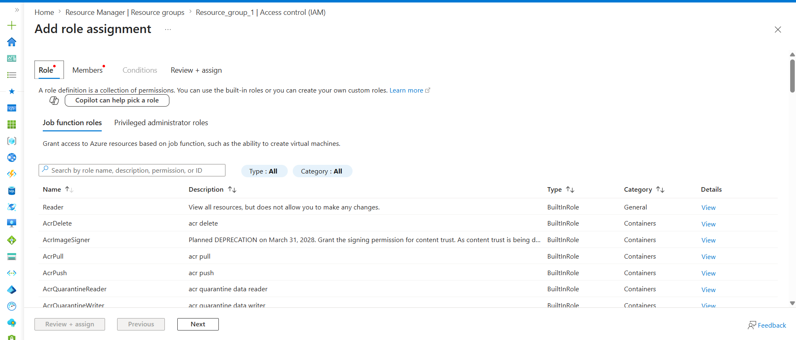

Selected the required user
Here we can select either Group or User
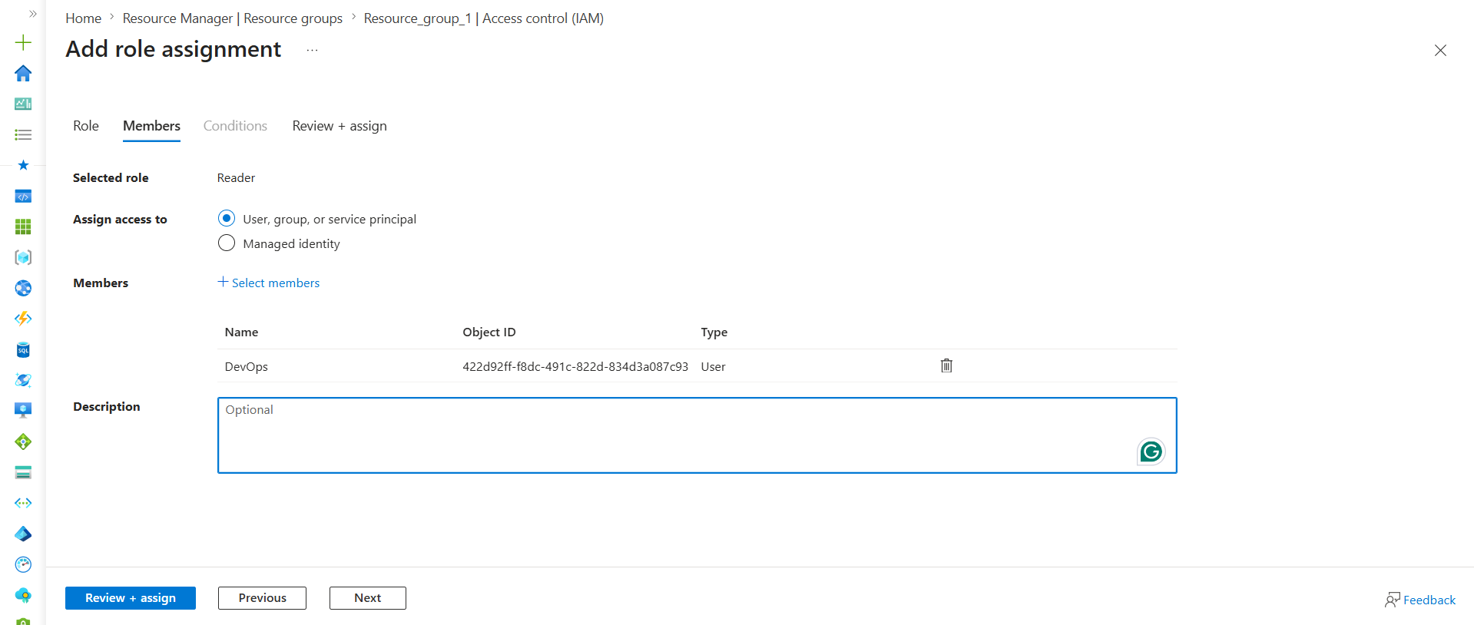
Easy Analogy
Reader = Visitor
Contributor = Employee
Owner = Manager

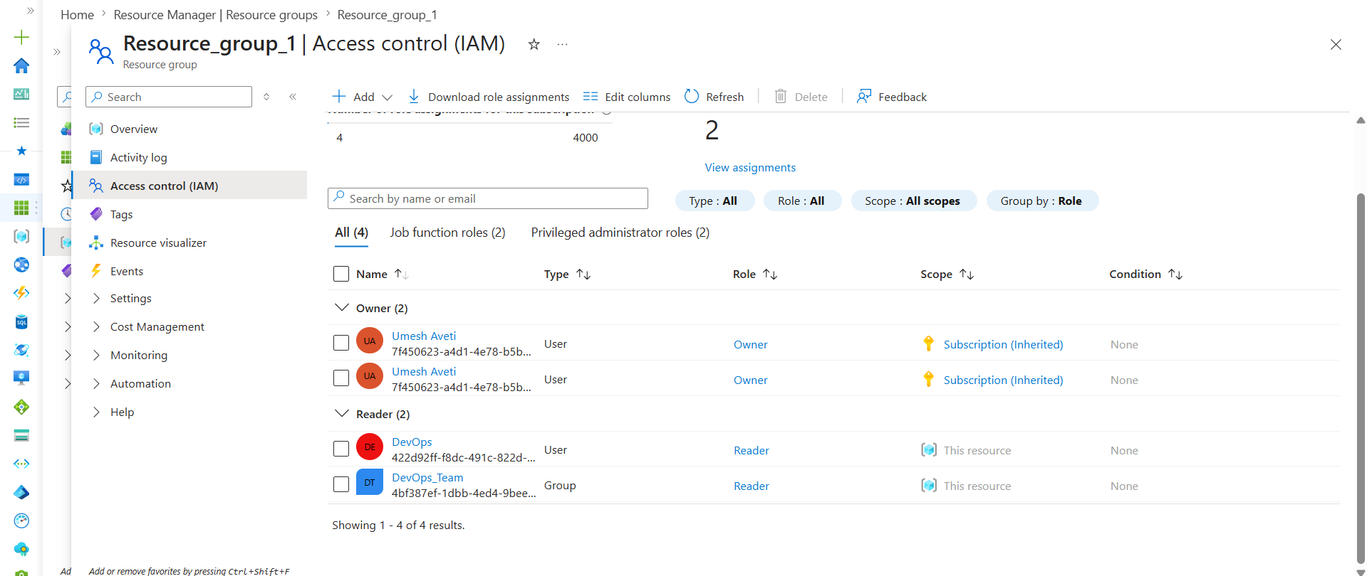

Role | What can do?
Reader | View resources only
Contributor | View, create, modify, delete resources
Owner | Contributor permissions + manage access (RBAC)
Reader
Can View Resources ✅
Can Create Resources ❌
Can Modify Resources ❌
Can Delete Resources ❌
Can Assign Roles ❌
Contributor
Can View Resources ✅
Can Create Resources ✅
Can Modify Resources ✅
Can Delete Resources ✅
Can Assign Roles ❌
Owner
Can View Resources ✅
Can Create Resources ✅
Can Modify Resources ✅
Can Delete Resources ✅
Can Assign Roles ✅
Azure RBAC permissions are inherited through the scope hierarchy. When a role is assigned at the Resource Group level, all resources inside that Resource Group automatically inherit the assigned permissions. For example, assigning the Reader role on a Resource Group grants Reader access to all VMs, Storage Accounts, AKS Clusters, ACRs, and other resources within that Resource Group. This simplifies access management by allowing permissions to be assigned once at a parent scope instead of individually on each resource.

AWS | Azure
IAM User | Entra ID User
IAM Group | Entra ID Group
IAM Role | RBAC Role / Managed Identity
IAM Policy | RBAC Permissions (inside Roles)
AWS Account | Azure Tenant
Assume Role | Managed Identity / Service Principal

Service Principal
A Service Principal is a non-human identity used by applications, automation tools, and CI/CD pipelines to access Azure resources. It acts like a dedicated Azure account for applications such as Azure DevOps, Terraform, Jenkins, or GitHub Actions. RBAC roles are assigned to the Service Principal to control its permissions. Applications authenticate using the Service Principal and perform actions based on the assigned role.
Managed Identity
Managed Identity is an Azure-managed identity assigned directly to an Azure resource such as a Virtual Machine, AKS Cluster, App Service, or Function App. It allows the resource to securely access other Azure services without storing usernames, passwords, or secrets. RBAC roles are assigned to the Managed Identity to grant the required permissions. Managed Identity is commonly used to access Storage Accounts, Key Vaults, and Azure Container Registries.
One-Line Difference
Service Principal is an identity for external applications and automation tools, whereas Managed Identity is an identity automatically managed by Azure for Azure resources.
Easy way to remember:
Human → User
Application → Service Principal
Azure Resource → Managed Identity

These are very common Azure DevOps interview questions. Keep the answers simple and practical.

1. What is the difference between RBAC and Entra ID?
Microsoft Entra ID is Azure's identity service that manages users, groups, applications, and authentication. RBAC (Role-Based Access Control) is Azure's authorization mechanism that controls what actions an identity can perform on Azure resources. Entra ID answers "Who are you?", while RBAC answers "What are you allowed to do?".

2. What is the difference between Service Principal and Managed Identity?
A Service Principal is a non-human identity used by applications, automation tools, and CI/CD pipelines such as Azure DevOps, Terraform, and GitHub Actions. A Managed Identity is an Azure-managed identity assigned directly to Azure resources such as VMs, AKS, and App Services. Service Principals are typically used by external tools, while Managed Identities are used by Azure resources.

3. What is the difference between Reader, Contributor, and Owner?
Reader can only view Azure resources and configurations. Contributor can create, modify, and delete resources but cannot manage access permissions. Owner has full access to resources and can also assign or remove RBAC permissions for other users and groups.

